|  |  |
| --- | --- |
| **Project Case** |  |
| COMP6144  Web Programming |
| **Computer Science** | **O202-COMP6144-SV03-00** |
| ***Valid on*** *Odd Semester Year 2020/2021* | **Revision 00** |

1. Seluruh kelompok tidak diperkenankan untuk:

*The whole group is not allowed to:*

* + - Melihat sebagian atau seluruh proyek kelompok lain,

*Seeing a part or the whole project from other groups*

* + - Menyadur sebagian maupun seluruh proyek dari buku,

*Adapted a part or the whole project from the book*

* + - Mendownload sebagian maupun seluruh proyek dari internet,

*Downloading a part or the whole project from the internet,*

* + - Mengerjakan soal yang tidak sesuai dengan tema yang ada di soal proyek,

*Working with another theme which is not in accordance with the existing theme in the matter of the project,*

* + - Melakukan tindakan kecurangan lainnya,

*Committing other dishonest actions,*

* + - Secara sengaja maupun tidak sengaja melakukan segala tindakan kelalaian yang menyebabkan hasil karyanya berhasil dicontek oleh orang lain / kelompok lain.

*Accidentally or intentionally conduct any failure action that cause the results of the project was copied by someone else / other groups.*

1. Jika kelompok terbukti melakukan tindakan seperti yang dijelaskan butir 1 di atas, maka **nilai kelompok** yang melakukan kecurangan (menyontek maupun dicontek) akan di – **NOL** – kan.

*If the group is proved to the actions described in point 1 above, the score of the group which committed dishonest acts (cheating or being cheated) will be “Zero”*

1. Perhatikan jadwal pengumpulan proyek, segala jenis pengumpulan proyek di luar jadwal tidak dilayani.

*Pay attention to the submission schedule for the project, all kinds of submission outside the project schedule will not be accepted*

1. Jangan lupa untuk melihat kriteria penilaian proyek yang ditempel di papan pengumuman, atau tanya asisten anda.

*Don’t forget to look at the project assessment criteria that posted on the announcement board, or ask your teaching assistant.*

1. Persentase penilaiaan untuk matakuliah ini adalah sebagai berikut:

*Marking percentage for this subject is described as follows:*

|  |  |  |
| --- | --- | --- |
| **Tugas Mandiri**  *Assignment* | **Proyek**  *Project* | **UAP**  *Final Exam* |
| - | 100% | - |

1. Software yang digunakan pada matakuliah ini adalah sebagai berikut:

*Software will be used in this subject are described as follows:*

|  |
| --- |
| **Software**  *Software* |
| PHP Composer 1.10.7  PHP Storm 2020.1.2  Visual Studio Code  Laravel Framework 7  XAMPP 7.4.7  Firefox / Chrome |

## Ekstensi file yang harus disertakan dalam pengumpulan tugas mandiri dan proyek untuk matakuliah ini adalah sebagai berikut:

*File extensions should be included in assignment and project collection for this subject are described as follows:*

|  |  |
| --- | --- |
| **Tugas Mandiri**  *Assignment* | **Proyek**  *Project* |
| - | Folder Project (PHP, SQL, Image Files (JPG / PNG), ENV, HTML, CSS, SCSS, JS, JSON, HTACCESS, ARTISAN) |

## Soal

*Case*

General Provisions:

* Use **MySQL** asdatabase and must using **Laravel Migration** features.
* **All file upload** feature such as image and document must be **stored to server storage**.
* Use PHP Framework **Laravel 7** to build the project.
* Use Laravel **MVC** concept (**Model, View, Controller**) to build the project.
* Use **Eloquent Query / Query Builder** to work with database.
* You are free to design your own database table **based on given requirements**.
* Print screen given below is only an example. You are free to create your own user interfaces.
* It is **prohibited** to install any kind of Laravel packages. You must use fresh installation of **Laravel 7**.
* Only **validation** in the **backend** (using Laravel) will be graded.

**Bjora**

**Bjora** is famous announcer company in Indonesia. To have a better engagement with their customers, **Bjora** company wants to create a website for their **QnA** (**question-and-answer**)website. In that website, user could find any information discussed by the community.

As a web developer, you are asked to create a website using **Laravel 7** for this question thread. There are threetypes of user’s role in this website: **Admin**, **Member**, and **Guest** (**non-logged-in user**). For each role, the website must contain at least these pages:

* + - Admin
* Home
* Answer
* Profile
* Inbox
* Master User
* Master Question
* Master Topic
  + - Member
* Home
* Answer
* Profile
* Inbox
* My Question
  + - Guest
* Login
* Register
* Home

Each page shows **greeting to user** and **current date time**. The descriptions for each page are:

1. Login

This page is accessible only to **guest**. This page allows user to log in to the website. Display an **error message** on the login page if user enters wrong combination of **Email** and **Password**.

If user has entered correct **Email** and **Password**, redirect user to the **Home Page** based on the user’s role. If user checks the “**Remember Me**” checkbox, the website will save the **Email** and **Password** using cookies.

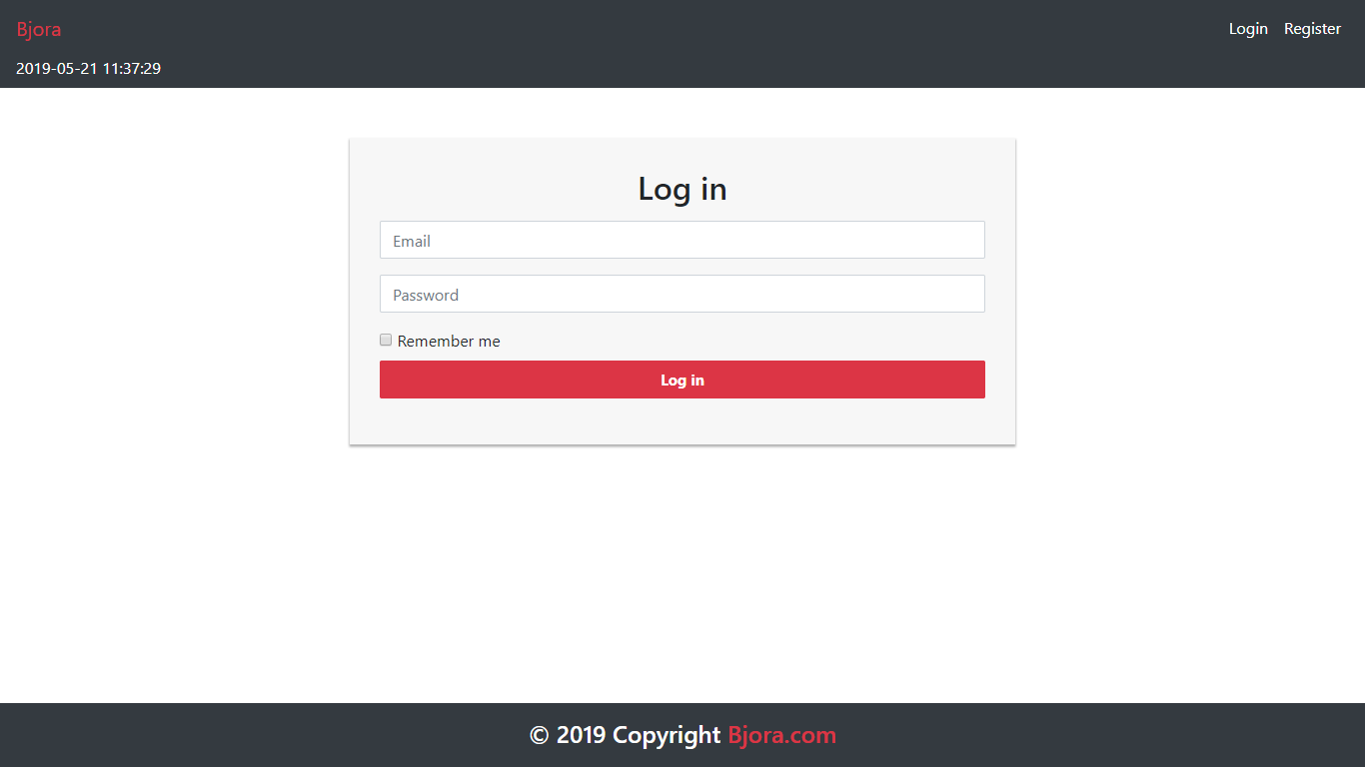

Figure . Login Page

1. Register

This page is accessible only to **guest**. This page allows guests to **register** themselves as a **Bjora** member. Display an **error message** if user input incorrect personal data.

The following table shows the existing fields on this page and the validation for each field:

|  |  |
| --- | --- |
| **Field** | **Information** |
| **Username** | Must be **filled** with **at most 100 characters** |
| **Email** | Must be **filled** with **email** and **unique** |
| **Password** | Must be **filled** with **at least 6 characters** and **alphanumeric format** |
| **Confirm Password** | Must be **filled** and **same with password** |
| **Gender** | Must be **selected** |
| **Address** | Must be **filled** |
| **Profile Picture** | Must be **selected** and must **match** one of the **allowed MIME types** (**jpeg**, **png**, **jpg**) |
| **Birthday** | Must be **filled** with **date format** |

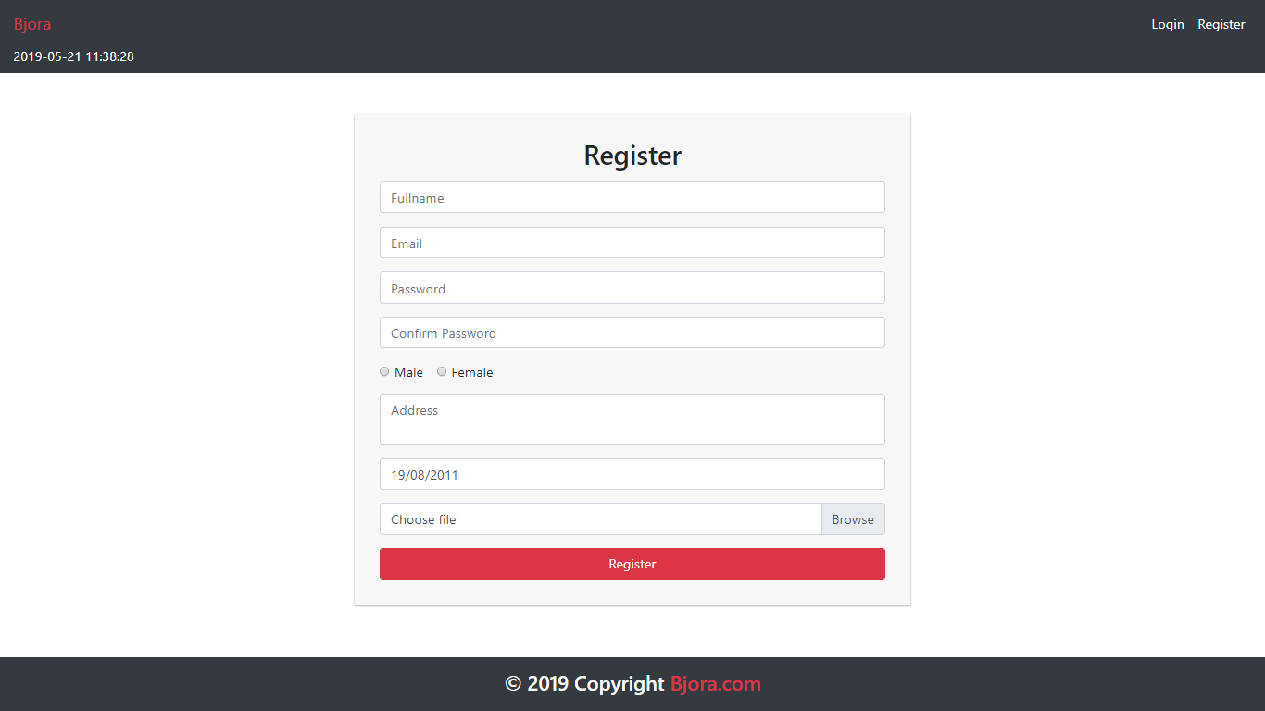

Figure 2. Register Page

1. Home

This page is accessible to **all users**. This page allows user to see all **Bjora** thread discussed by the community. This page allows user to **search thread by either question** or **username**. Bjora question is displayed using **pagination** with **10** **questions for each page**.

In navigation bar, there is an **Add Question** button. The **Add Question** button is visible if the **user** has **logged in**. If user clicks **Add Question** button, then the user will be redirected to **Add Question Page**.

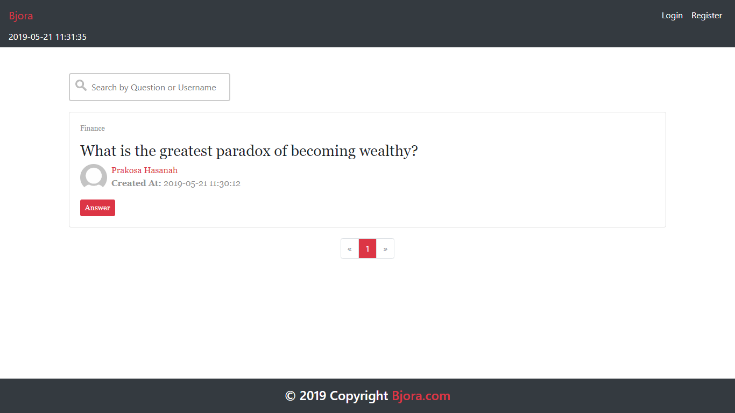

Figure 3. Home Page (for Guest)

Figure 4. Home Page (for Member and Admin)

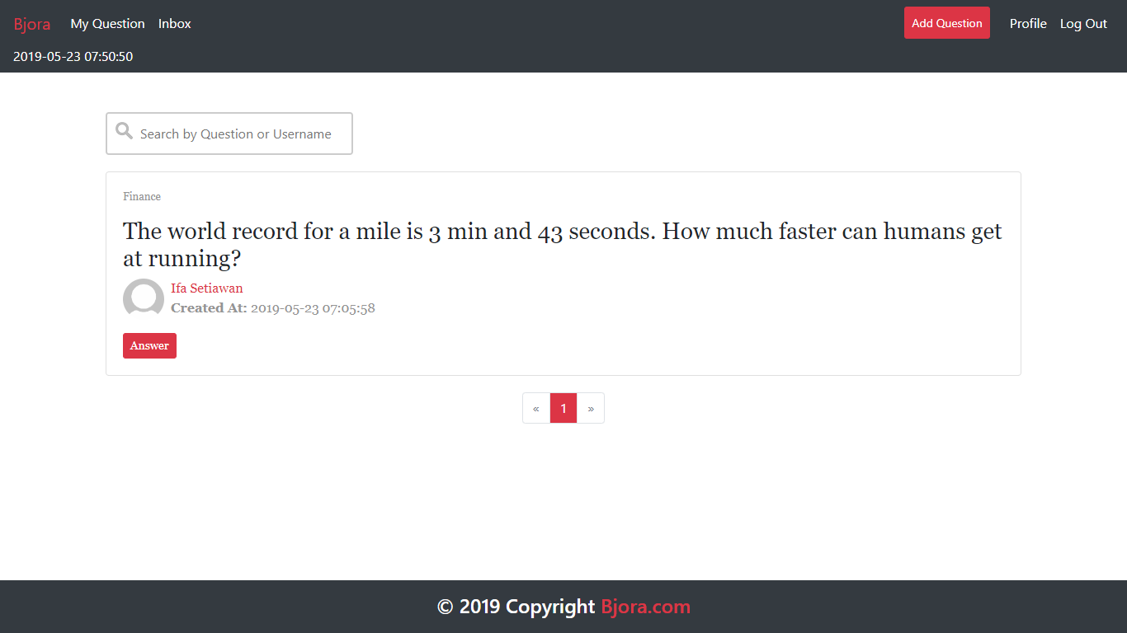

Figure 5. Searching Question with 'How' Keyword

1. Add Question Page

This page is accessible for **member** and **admin**. This page allows user to **insert** new question. Display **error message** if user input incorrect question data. The following table shows existing fields in the **Add Question Page** and the validation for each field:

|  |  |
| --- | --- |
| **Field** | **Information** |
| **Question** | Must be **filled** |
| **Topic** | Must be **selected** |

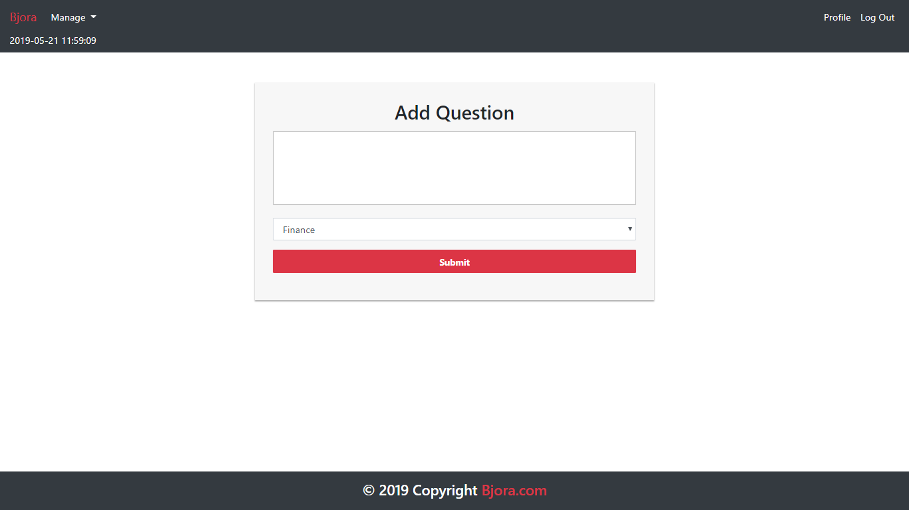

Figure 6. Add Question Page

1. Update Question Page

This page is accessible to **member** and **admin**. This page allows user to **update** their ownquestion. Display **error message** if user input incorrect question data. The following table shows existing fields in the **Update Question Page** and the validation for each field:

|  |  |
| --- | --- |
| **Field** | **Information** |
| **Question** | Must be **filled** |
| **Topic** | Must be **selected** |

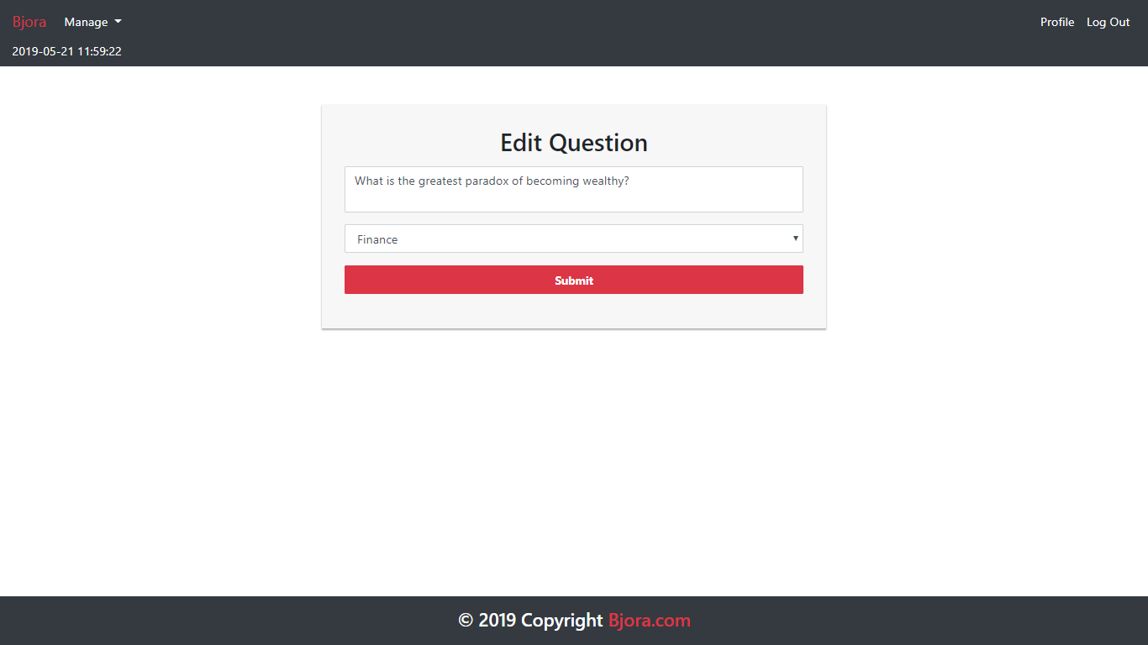

Figure 7. Update Question Page

1. Answer Page

This page is accessible to **all users**. This page can be accessed if user clicks **Answer** button in **Home page**. This page allows user to **view and answer** the selected question. Display question information such as **question’s status** (**open** or **closed**), **question’s owner**, **question’s creation date**, **answer**, **answer’s** **owner**, and **answer’s creation** **date**. Make sure all **question’s owner and answer’s owner name** can be clicked. Redirect user to **profile page** if user clicked the user’s name.

User could **post** an answer to the current question by using the form below the question. Show the form only to **member** and **admin**. The requirements for each field are:

|  |  |
| --- | --- |
| **Field** | **Information** |
| **Answer** | Must be **filled** |

The user can also **update** or **remove** their **own answer**. Validate that the **update** and **delete** buttons only appeared to **the current logged in user**’**s answer**. If **user** clicked the **update** **button**, redirect user to **Update Answer** **Page**. If user clicked the **delete** button, then **delete** the selected answer.

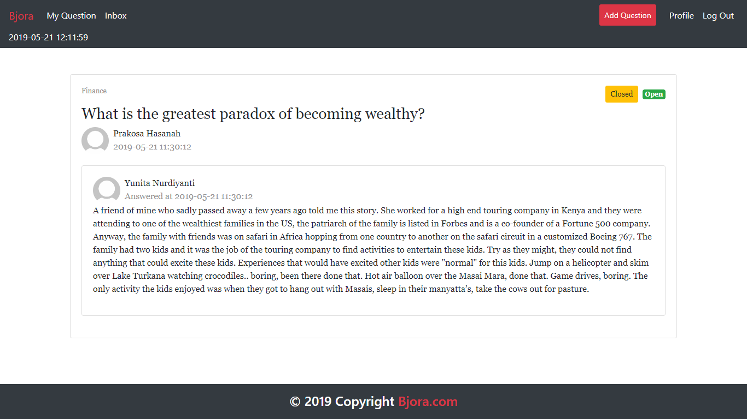

Figure 8. Answer Page (Opening Current Logged in User)

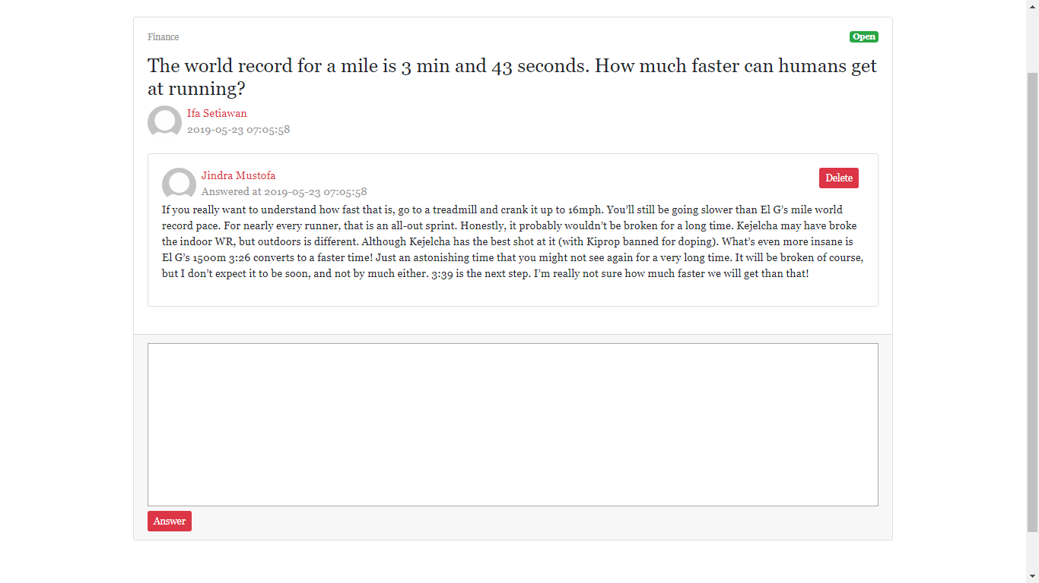

Figure 9. Answer Page (Viewing Another User Answer)

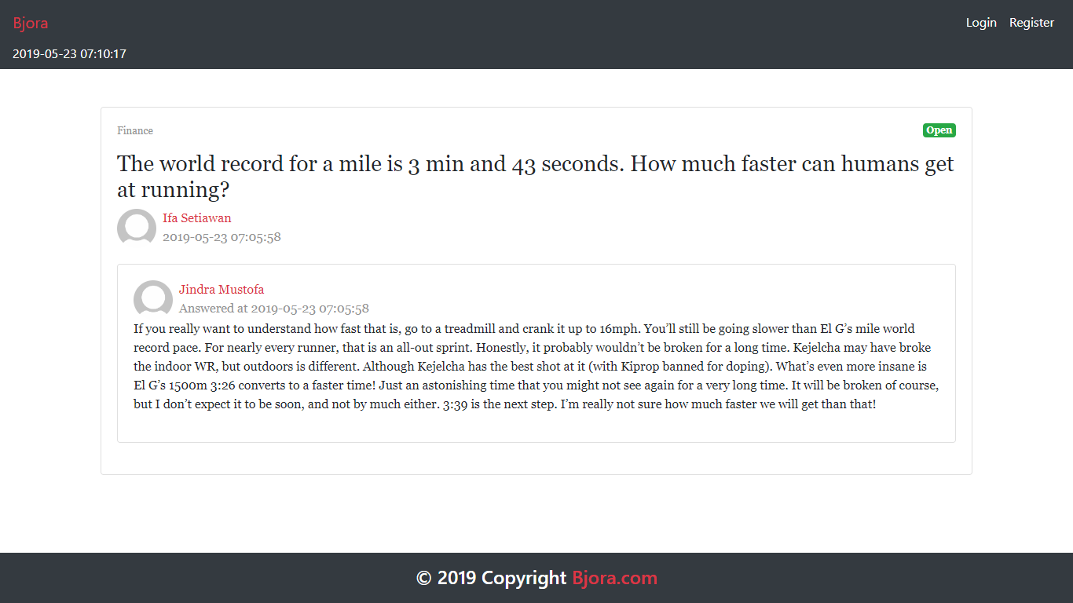

Figure 10. Answer Page (for Guest)

1. Profile Page

This page is accessible to **member** and **admin**. This page allows user to **see their profile** or **another** **user**’**s** **profile**.

There are some requirements on this page:

* If the user is viewing their own profile, validate that only **Edit** button is **visible**. If user clicks the **Edit** button, then redirect user to **Edit Profile** page
* If the user is viewing others user’s profile, validate that only **Send Message** form is visible. If user clicks the **Send Message** button, validate that the **message** field must be **filled** beforehand, and then send the **corresponding message** to the user

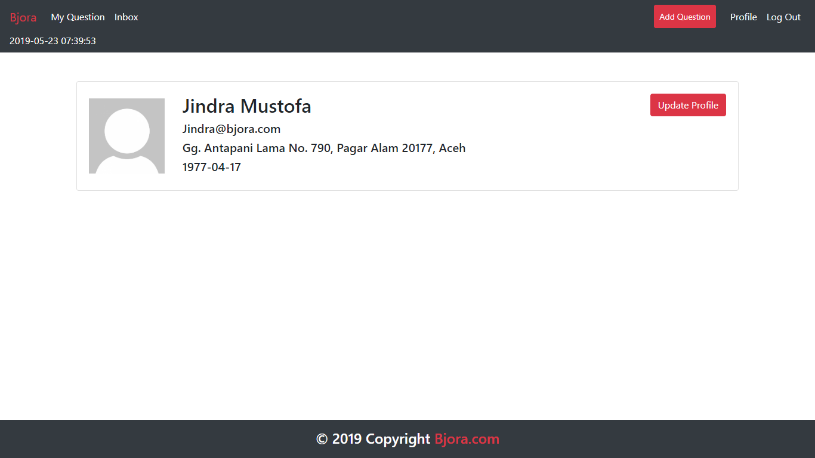

Figure 11. Profile Page (Opening Current Logged in User)

Figure 12. Profile Page (Viewing Another User Profile)

1. Inbox Page

This page is accessible to **member** and **admin**. This page allows user to **view** and **delete** messages they received. Display message information such as **message’s content**, **message’s sender**, and **message’s creation date**. In this page, all messages displayed using **pagination** with **10 messages each page**. If user click **Delete button**, then **delete** the selected message.

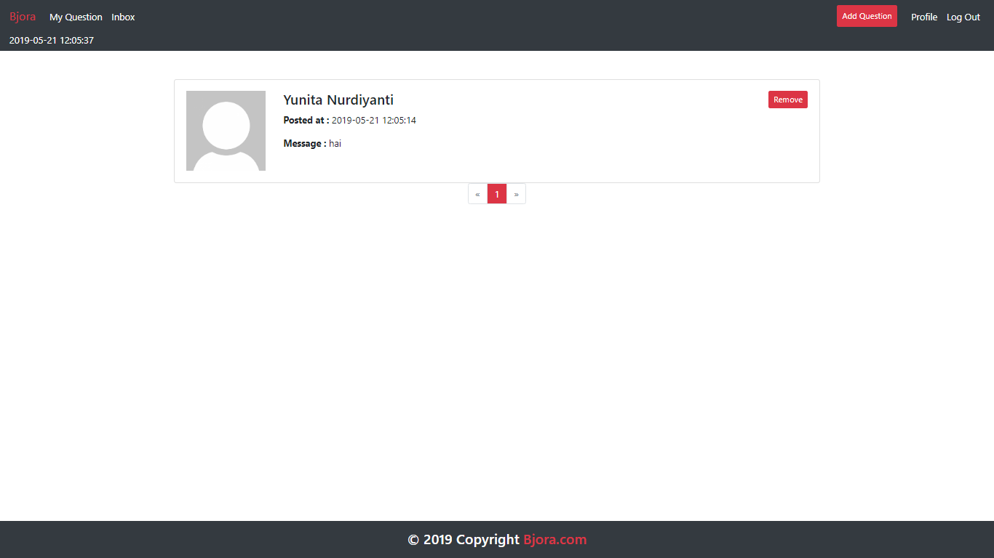

Figure 13. Inbox Page

1. My Question Page

This page is accessible to **member** and **admin**. This page is accessible by clicking **My Question** in navigation bar. This page **shows** all **question** that user has posted by using **pagination** with **10** **questions per page** and allows user to **edit** or **close** that question.Display question information such as **question’s content** and **question’s status**.

Each question in the lists have ‘**Edit**’ and ‘**Delete**’ buttons:

* If user click **Edit** button, redirect user to **Update Question Page**
* If user click **Close** button, change the **selected** question **status** to ‘**Closed**’. Validate ‘**Close**’ **button** only **enabled** for question that the **status** still ‘**Open**’

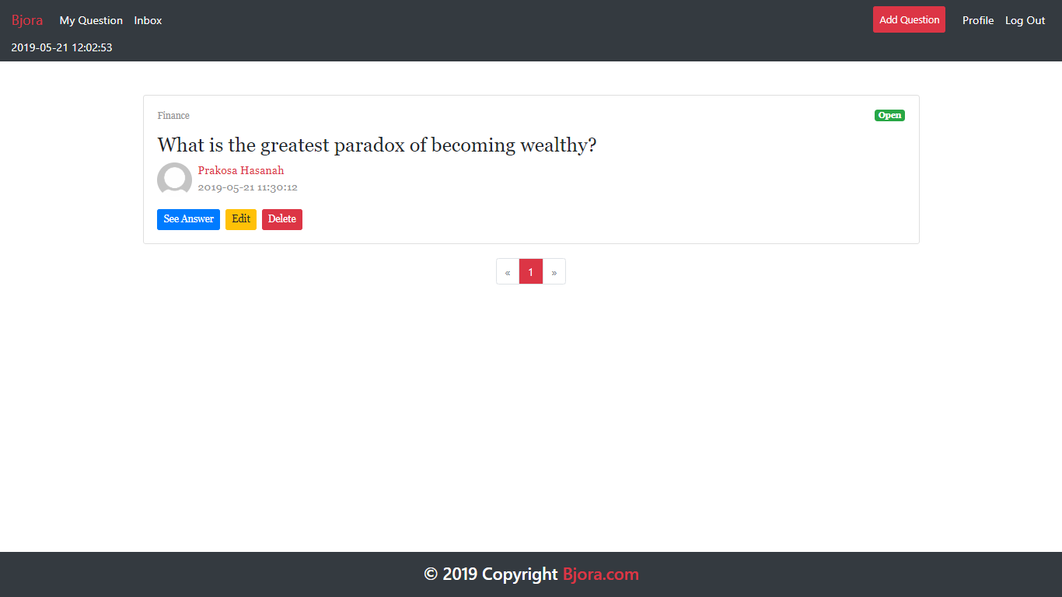

Figure 14. My Question Page

1. Master User Page

This page is accessible only to **admin**. This page shows all users using **pagination** with **10** **users each page**.

In this page, there are ‘**Add New User**’, ‘**Edit**’, and ‘**Delete**’ button:

* If user click **Add New User** button, redirect user to **Add User Page**
* If user click **Edit** button, redirect user to **Update User Page**
* If user click **Delete** button, **delete** selecteduser

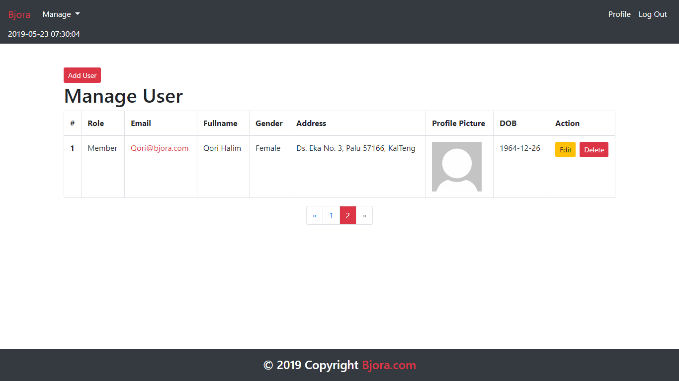

Figure 15. Master User Page

1. Add User Page

This page allows **Admin** to **add new user**. Display **error message** if user input incorrect user data. The following table shows existing fields in the **Add User Page** and the validation for each field:

|  |  |
| --- | --- |
| **Field** | **Information** |
| **Name** | Must be **filled** with **at most 100 characters** |
| **Role** | Must be **selected** |
| **Email** | Must be **filled** with **email** and **unique** |
| **Password** | Must be **filled** with **at least 6 characters** and **alphanumeric format** |
| **Confirm Password** | Must be **filled** and **same with password** |
| **Gender** | Must be **selected** |
| **Address** | Must be **filled** |
| **Profile Picture** | Must be **selected** and must **match** one of the **allowed MIME types** (**jpeg**, **png**, **jpg**) |
| **Birthday** | Must be **filled** with **date format** |

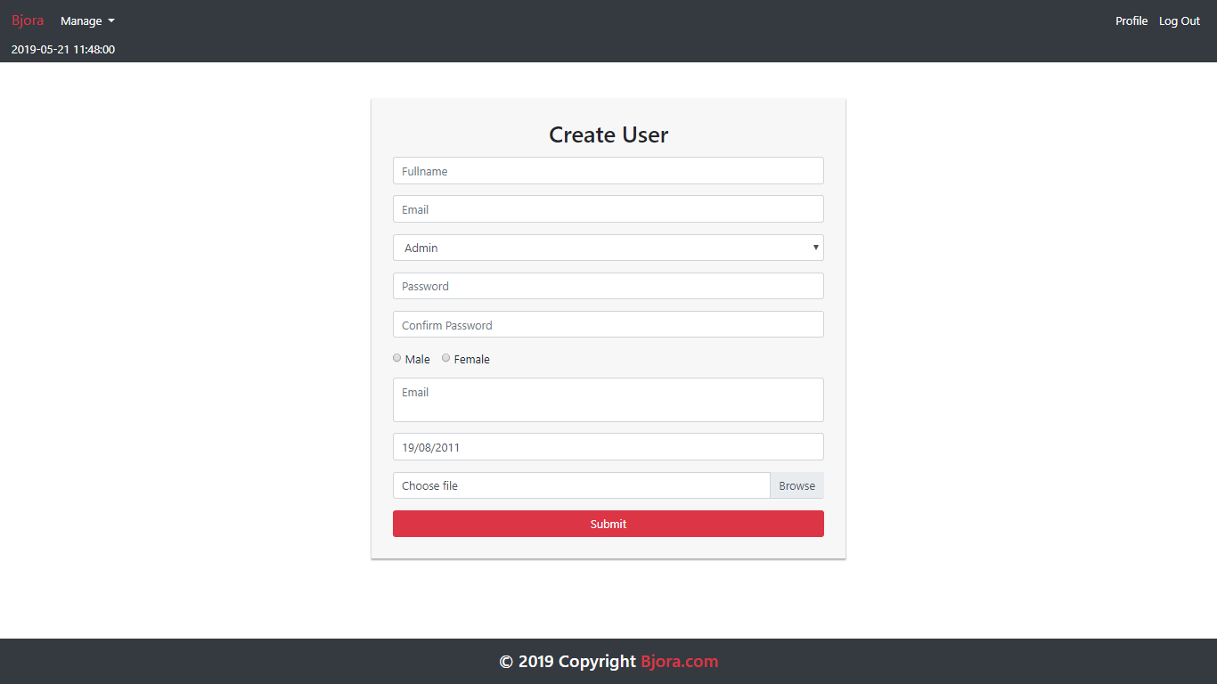

Figure 16. Add User Page

1. Edit Profile Page

This page allows user to **update** their profile data. Display **error message** if user input incorrect user data.

The following table shows existing fields in the **Edit Profile Page** and the validation for each field:

|  |  |
| --- | --- |
| **Field** | **Information** |
| **Name** | Must be **filled** with **at most 100 characters** |
| **Email** | Must be **filled** with **email** and **unique** |
| **Password** | Must be **filled** with **at least 6 characters** and **alphanumeric format** |
| **Confirm Password** | Must be **filled** and **same with password** |
| **Gender** | Must be **selected** |
| **Address** | Must be **filled** |
| **Profile Picture** | Must be **selected** and must **match** one of the **allowed MIME types** (**jpeg**, **png**, **jpg**) |
| **Birthday** | Must be **filled** with **date format** |

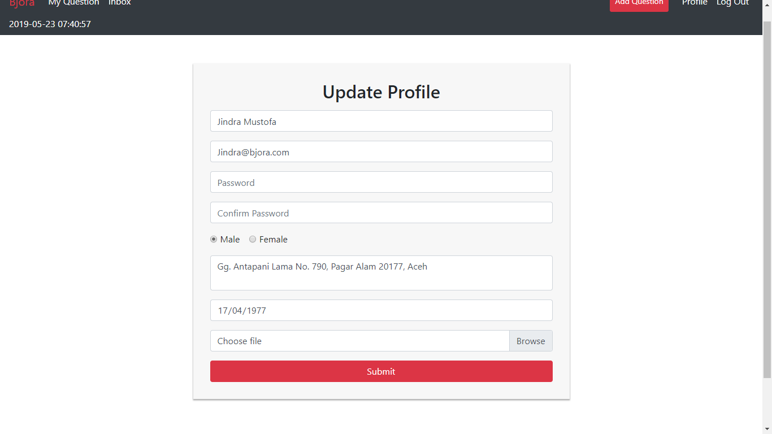

Figure 17. Edit Profile Page

1. Update User Page

This page allows **Admin** to **update** user data. Display an **error message** if user input incorrect data.

The following table shows existing fields in the **Edit Profile Page** and the validation for each field:

|  |  |
| --- | --- |
| **Field** | **Information** |
| **Name** | Must be **filled** with **at most 100 characters** |
| **Role** | Must be **selected** |
| **Email** | Must be **filled** with **email** and **unique** |
| **Password** | Must be **filled** with **at least 6 characters** and **alphanumeric format** |
| **Confirm Password** | Must be **filled** and **same with password** |
| **Gender** | Must be **selected** |
| **Address** | Must be **filled** |
| **Profile Picture** | Must be **selected** and must **match** one of the **allowed MIME types** (**jpeg**, **png**, **jpg**) |
| **Birthday** | Must be **filled** with **date format** |

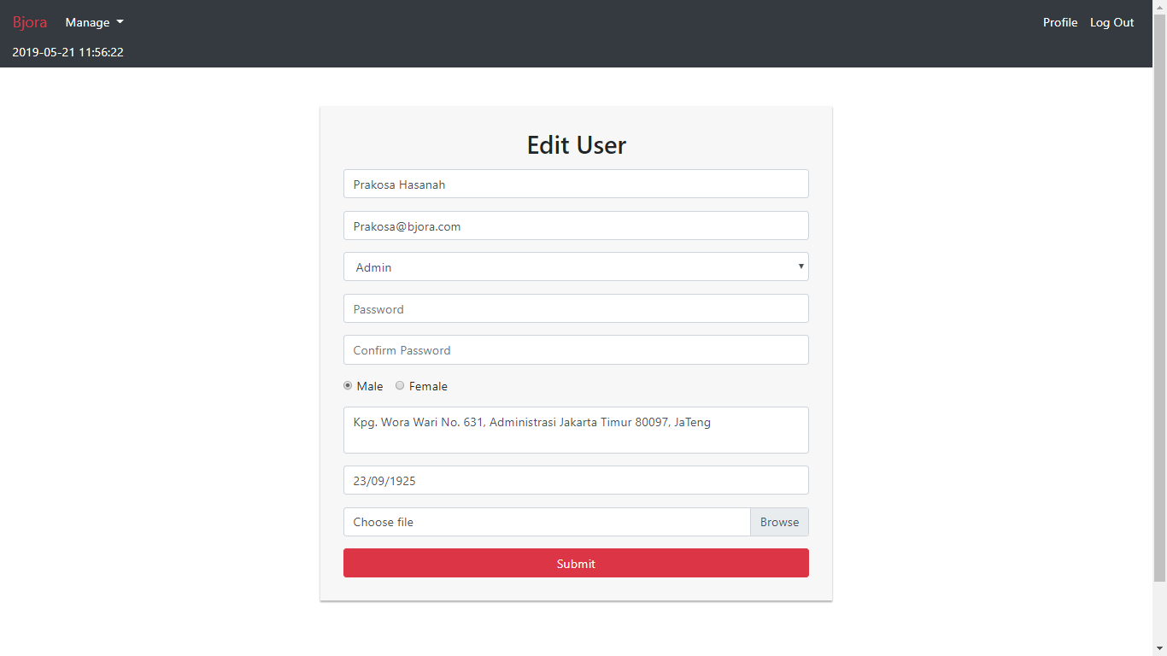

Figure 18. Update User Page

1. Master Question Page

This page is accessible only to **admin**. This page shows all questions using **pagination** with **10** threads each page.

In this page, there are ‘**Delete**’ button and ‘**Close**’button:

* If user click ‘**Delete**’ **button**, **delete** the question
* If user click ‘**Close**’ **button**, **update** selected question **status** to ‘**Closed**’. Validate ‘**Close**’ **button** only **enabled** for question that the **status** still ‘**Open**’

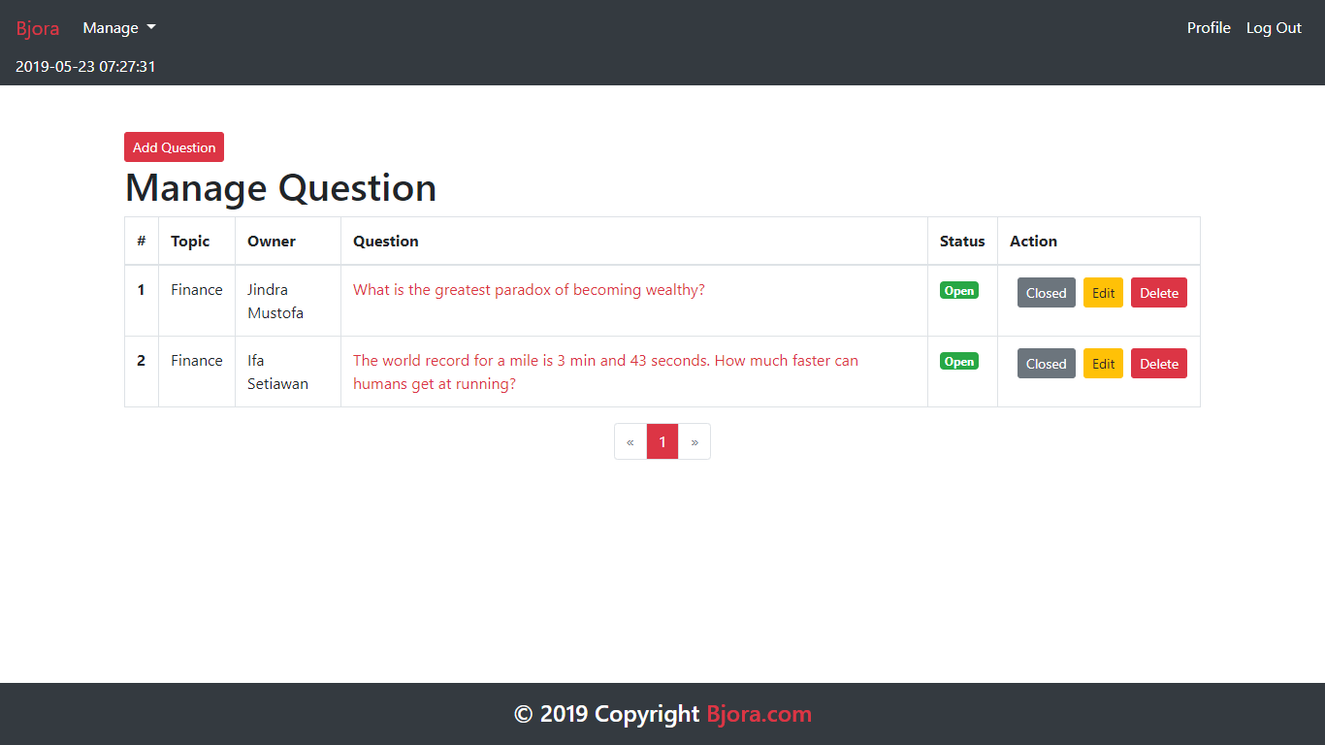

Figure 19. Master Thread Page

1. Master Topic Page

This page is accessible only to **admin**. This page allows **Admin** to manage all topics. In this page, there are ‘**Add**’, ‘**Edit**’, and ‘**Delete**’ button:

* If user click **Add button**, validate **name field** must be **filled** before user can **add** the topic. Display error message if user input incorrect topic data
* If user click **Edit** **button**, redirect user to **Edit Topic Page**
* If user click **Delete** **button**, **delete** the selected topic

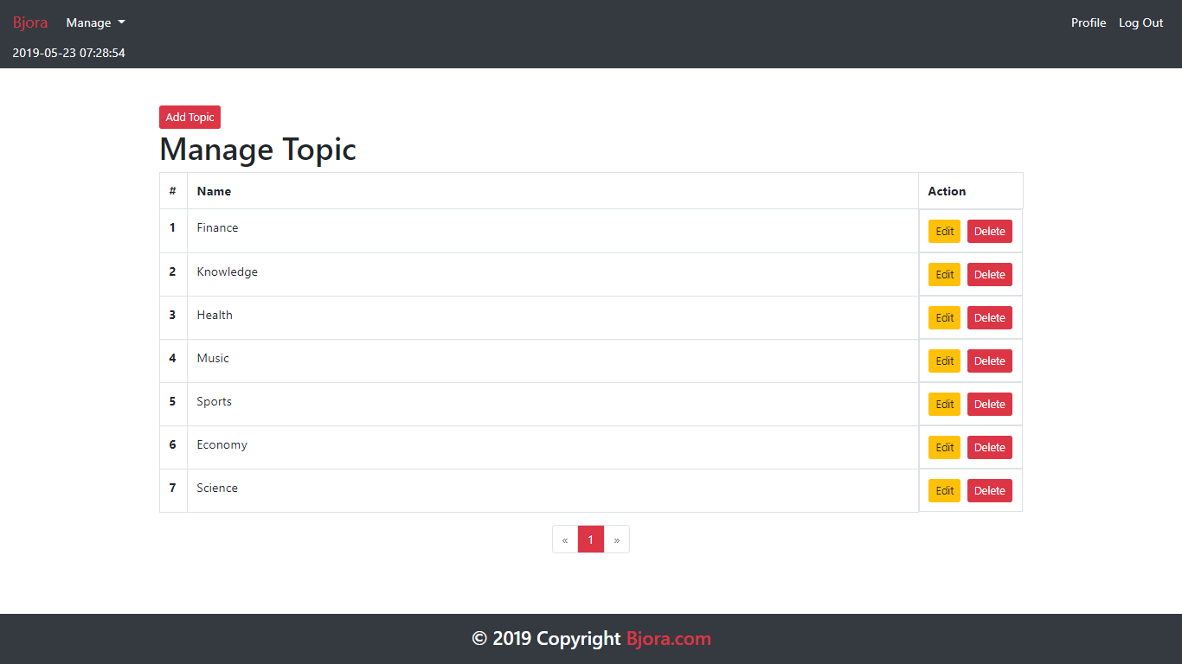

Figure 20. Master Category Page

1. Update Topic Page

This page allows user to **update** **topic’s** **name**. The **name field** must be **filled** before user click **Update button**. If the user clicks **Update button**, then **update** **selected topic**.

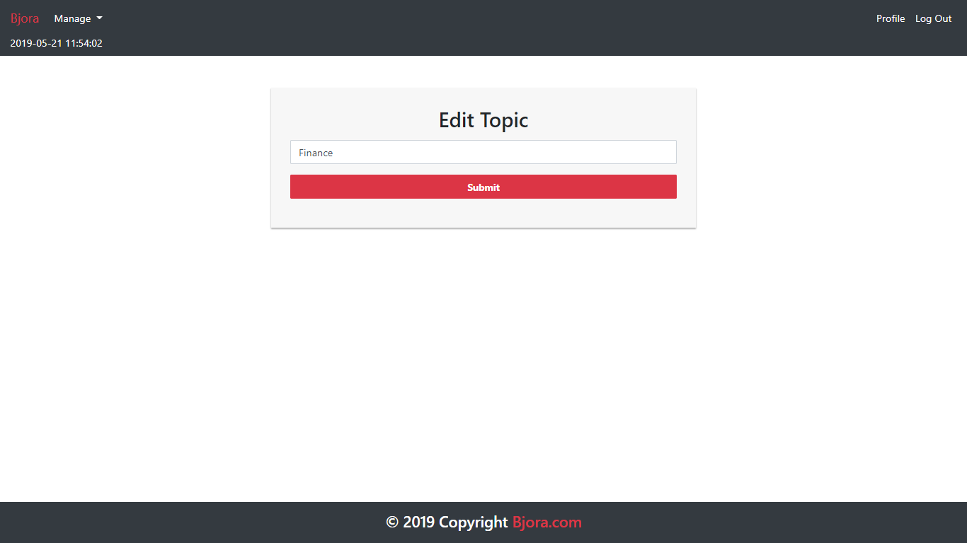

**Figure 21. Edit Category Page**

Here are the rules that you must follow to create your project:

1. Use appropriate software for this subject based on **Sistem Praktikum** that can be downloaded from Binusmaya.
2. Collect appropriate files for this subject based on **Sistem Praktikum** that can be downloaded from Binusmaya.
3. Include the other files that can support your project, such as:
   * All files in your project
   * Other files (image, audio, video, etc.) used in your project
   * *.DOC file (documentation of your project) that contains all pages in your project, reference links of additional files (image, audio, video, etc.) used in your project, the description about how to use your application, etc.
4. If there are some hidden creativities, please note them in the existing documentation because they can greatly affect your project score

**Reference**:

<https://cresscap.com/dummy-profile-pic/>